**LAB#12**

**OBJECT: Implement the circuit diagram of binary to gray code conversion.**

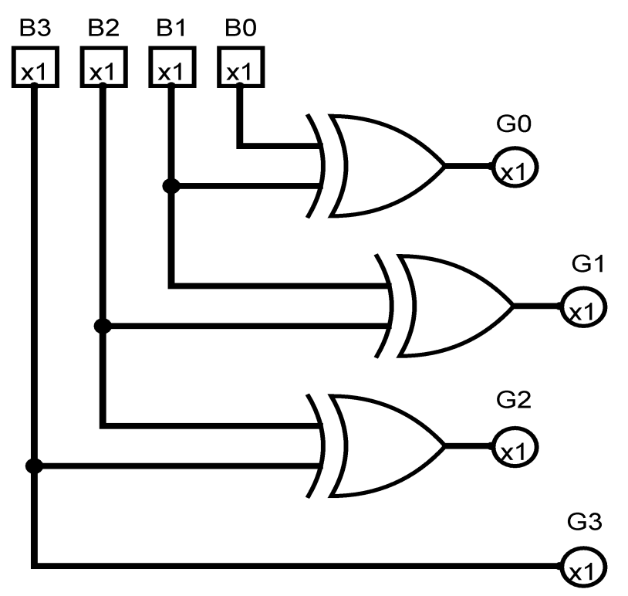

**APPARATUS:**

* 74LS86
* Bread Board
* Connecting Wires
* LED
* DC Supply

**SYMBOLS:**

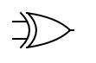

XOR GATE

**CIRCUIT DESIGN:**

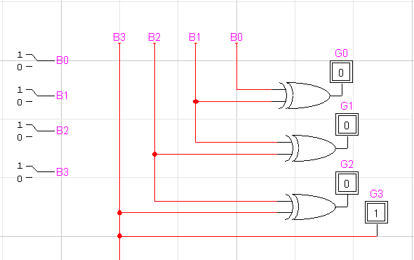

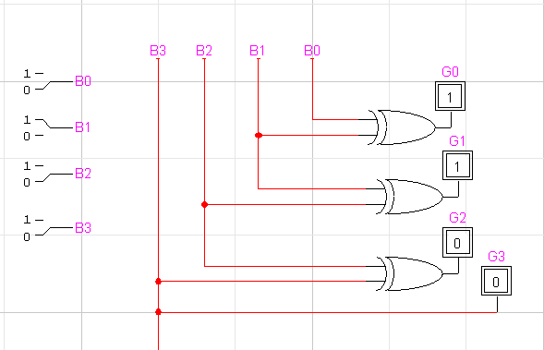

**CONCLUSION:**

The Binary to gray code conversion is accurate.